Easter Egg Roll Game

Feeling competitive? Have a go at this traditional Easter game.

You will need:
Hard-boiled eggs (one per player)
Pens/paints
Decorations e.g. wool, sequins, stickers.
Paper or card (for the crown).

How to play:
- Decorate your hard-boiled eggs with patterns, or as characters.
- Make one crown.

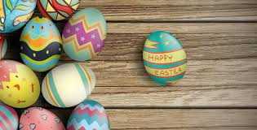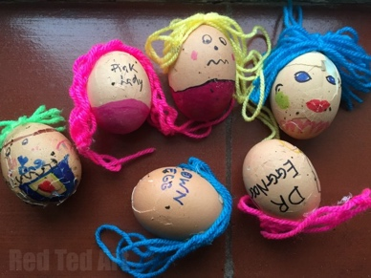

- Find a slope to roll your eggs down. If you don’t have a slope nearby, get some spoons or rolled up newspaper and tap the egg along the ground.
- Mark out a start line.
- Place your eggs on the start line.
- Count to 3, then let go of your eggs!

The winner:
The winner is the egg that has rolled the furthest or the egg that is broken the least. Don’t forget to crown the winner!

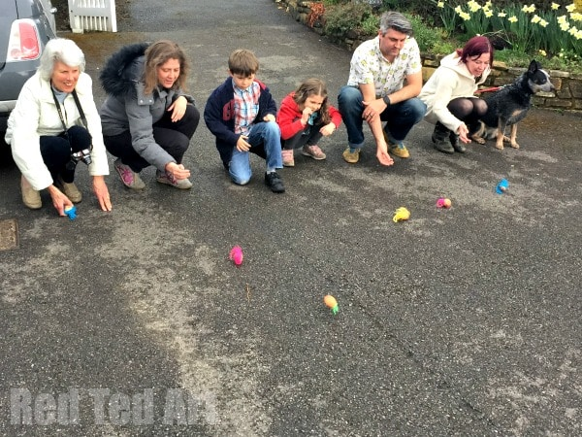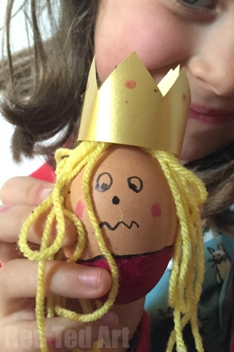

Remember: only play this game with members of your household.

